Lab3 CIS43 Due: 6/27/2016

Name: Nikhil Vytla

***Exercise: Ex 4.20, 4.21, 4.22, 4.37a***

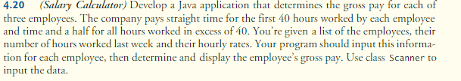

SalaryCalc

**package** P420;

**import** java.util.Scanner;

**public** **class** SalaryCalc {

**public** **static** **void** main(String[] args) {

Scanner input = **new** Scanner(System.*in*);

String name1, name2, name3;

**int** hour1, hour2, hour3;

**double** pay1, pay2, pay3, grossPay1, grossPay2, grossPay3;

System.*out*.printf("Enter Employee 1 name: %n");

name1 = input.next();

System.*out*.println("Enter Employee 1 hours: ");

hour1 = input.nextInt();

System.*out*.println("Enter Employee 1 pay: ");

pay1 = input.nextDouble();

System.*out*.printf("Enter Employee 2 name: %n");

name2 = input.next();

System.*out*.println("Enter Employee 2 hours: ");

hour2 = input.nextInt();

System.*out*.println("Enter Employee 2 pay: ");

pay2 = input.nextDouble();

System.*out*.printf("Enter Employee 3 name: %n");

name3 = input.next();

System.*out*.println("Enter Employee 3 hours: ");

hour3 = input.nextInt();

System.*out*.println("Enter Employee 3 pay: ");

pay3 = input.nextDouble();

**if** (hour1 <= 40)

grossPay1 = hour1 * pay1;

**else**

grossPay1 = (1.5 * (hour1-40) * pay1) + (40 * pay1);

**if** (hour2 <= 40)

grossPay2 = hour2 * pay2;

**else**

grossPay2 = (1.5 * (hour2-40) * pay2) + (40 * pay2);

**if** (hour3 <= 40)

grossPay3 = hour3 * pay3;

**else**

grossPay3 = (1.5 * (hour3-40) * pay3) + (40 * pay3);

System.*out*.printf("%s's gross pay is: %.2f%n", name1, grossPay1);

System.*out*.printf("%s's gross pay is: %.2f%n", name2, grossPay2);

System.*out*.printf("%s's gross pay is: %.2f%n", name3, grossPay3);

}

}

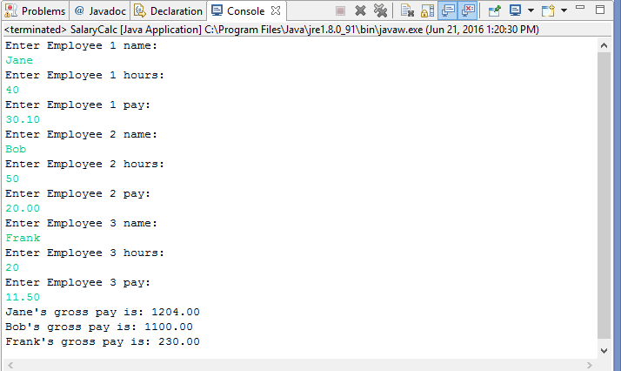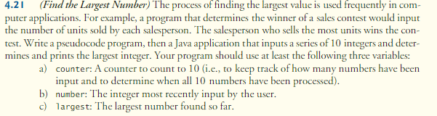

SalesContest

**package** P421;

**import** java.util.Scanner;

**public** **class** SalesContest {

**public** **static** **void** main(String[] args) {

Scanner input = **new** Scanner (System.*in*);

**int** counter = 1, number, largest;

System.*out*.println("Choose any ten numbers!");

System.*out*.print("Enter number 1: ");

largest = input.nextInt();

**while** (counter < 10){

System.*out*.printf("Enter number %d: ", counter + 1);

number = input.nextInt();

**if** (number > largest){

largest = number;

}

++counter;

}

System.*out*.printf("The largest number is: %d", largest);

}

}

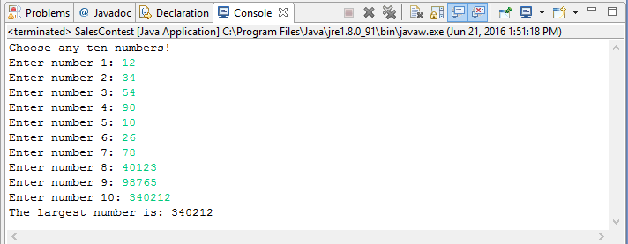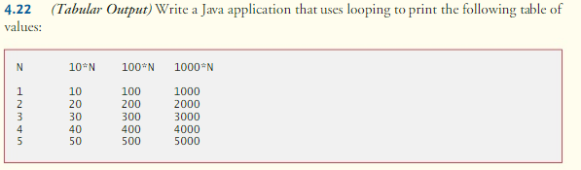

ValueTable

**package** P422;

**public** **class** ValueTable {

**public** **static** **void** main(String[] args) {

String w = "N", x = "10*N", y = "100*N", z = "1000*N";

System.*out*.printf("%s%10s%10s%10s",w,x,y,z);

**for** (**int** n = 1; n < 6; ++n){

System.*out*.printf("%n%s%8s%10s%10s", n,n*10,n*100,n*1000);

}

}

}

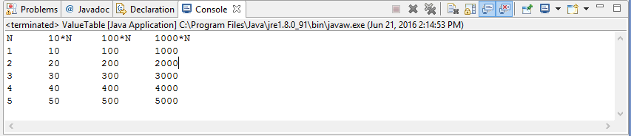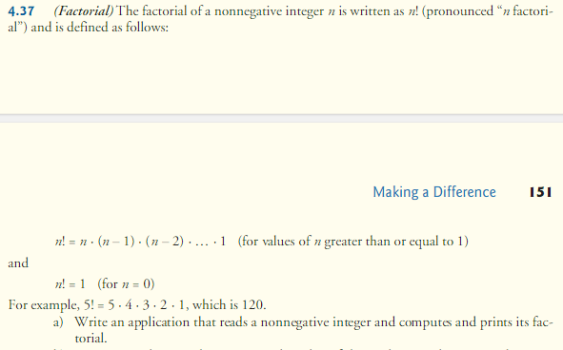

Factorials

**package** 437a

{

**import** java.util.Scanner;

**public** **class** Factorials

{

**public** **static** **void** main(String args[])

{

Scanner input = **new** Scanner(System.*in*);

**int** factorial = 1;

System.*out*.printf("Enter a number to find its factorial: ");

**int** number = input.nextInt();

**for** (**int** n = 1; n <= number; n++){

factorial = factorial*n;

}

System.*out*.println("The factorial of " + number + " is: " + factorial);

}

}

